Lab Exercise 4

IT4030 - Internet of Things (IoT) 2024


Lab 4: measure humidity and temperature using a NodeMCU (ESP8266) and a DHT11 sensor while publishing the data to Adafruit IO

B
Sc in
Information Technology

Year 4
-

Semester 1
/2

- Goto Adafruit and create a user account. (IO -> Feeds{Create two feeds})
Adafruit Industries, Unique & fun DIY electronics and kits

- i)Search “Nodemcu ESP8266 Preferences link” and copy the link or,
ii)visit Quick Start to Nodemcu (ESP8266) on Arduino IDE : 3 Steps (with Pictures) - Instructables or any suitable website and copy Preferences link or,
iii)use http://arduino.esp8266.com/stable/package_esp8266com_index.json
link as Preferences link.

- Goto Arduino IDE -> File -> Preferences -> Additional boards manager URLs ->
Paste the link -> OK

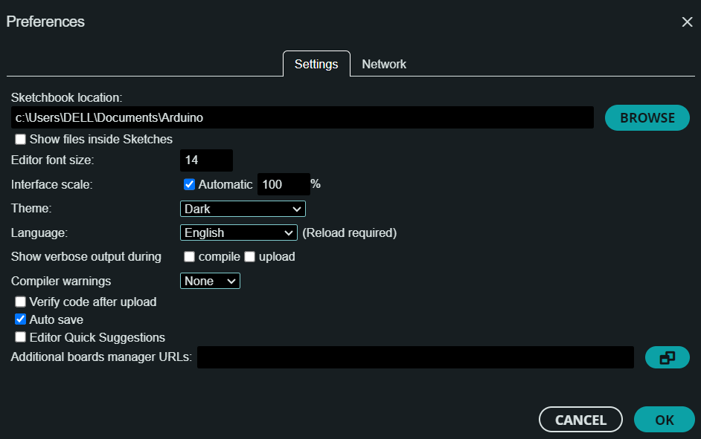

- Arduino IDE -> Tools -> Board -> Board Manager -> Search “esp8266” -> Install

- Arduino IDE -> Tools -> Board -> esp8266 -> Generic ESP8266 Module
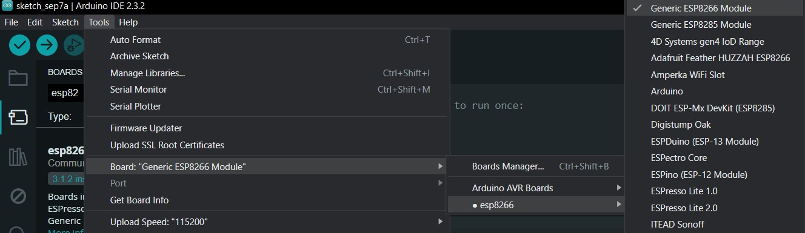

- Code
#include <ESP8266WiFi.h>
#include <Adafruit_MQTT.h>
#include <Adafruit_MQTT_Client.h>
#include <DHT11.h>

// Replace these with your network and Adafruit IO credentials
#define WIFI_SSID "wifiname"
#define WIFI_PASS "password"
#define AIO_SERVER "io.adafruit.com"
#define AIO_SERVERPORT 1883 // Use 8883 for SSL
#define AIO_USERNAME "hanojhanr"
#define AIO_KEY "aio_iRMM32P9cjTIzez13nlulpmfN0qj"

#define DHTPIN 4 // DHT11 sensor data pin connected to ESP8266 to pin 4
DHT11 dht11(DHTPIN);

WiFiClient client;
Adafruit_MQTT_Client mqtt(&client, AIO_SERVER, AIO_SERVERPORT, AIO_USERNAME, AIO_KEY);

// Setup feeds for temperature and humidity
Adafruit_MQTT_Publish temperatureFeed = Adafruit_MQTT_Publish(&mqtt, AIO_USERNAME "/feeds/temperature");
Adafruit_MQTT_Publish humidityFeed = Adafruit_MQTT_Publish(&mqtt, AIO_USERNAME "/feeds/humidity");

void setup() {
Serial.begin(115200);
delay(10);

// Connect to Wi-Fi
Serial.println(); Serial.println();
Serial.print("Connecting to ");
Serial.println(WIFI_SSID);

WiFi.begin(WIFI_SSID, WIFI_PASS);
while (WiFi.status() != WL_CONNECTED) {
delay(500);
Serial.print(".");
}
Serial.println();
Serial.println("WiFi connected");
Serial.println("IP address: "); Serial.println(WiFi.localIP());

// Connect to Adafruit IO
connectToAdafruitIO();

// Initialize the DHT sensor
// dht11.begin(); // Not needed for DHT11 library
}

void loop() {
// Ensure the connection to Adafruit IO is maintained
if (mqtt.connected()) {
mqtt.processPackets(10000);
mqtt.ping();
} else {
connectToAdafruitIO();
}

int temperature = 0;
int humidity = 0;

// Read temperature and humidity from DHT11
int result = dht11.readTemperatureHumidity(temperature, humidity);

// Check if any reads failed
if (result == 0) {
// Publish the data
Serial.print("Publishing temperature: "); Serial.println(temperature);
if (!temperatureFeed.publish(temperature)) {
Serial.println("Failed to publish temperature");
}

Serial.print("Publishing humidity: "); Serial.println(humidity);
if (!humidityFeed.publish(humidity)) {
Serial.println("Failed to publish humidity");
}
} else {
Serial.print("Failed to read from DHT sensor! Error: ");
Serial.println(DHT11::getErrorString(result));
}

// Wait for a few seconds before sending the next reading
delay(2000);
}

void connectToAdafruitIO() {
int8_t ret;

// Attempt to connect to Adafruit IO
Serial.print("Connecting to Adafruit IO... ");
while ((ret = mqtt.connect()) != 0) {
Serial.println(mqtt.connectErrorString(ret));
Serial.println("Retrying in 5 seconds...");
mqtt.disconnect();
delay(1000);
}
Serial.println("Adafruit IO connected!");
}

- Arduino IDE -> Tools -> Select correct Port (If port is not detected, download and install CH340 driver. Use this link CH340 Drivers for Windows, Mac and Linux (gogo.co.nz) or Google and download)

- Arduino IDE -> Tools -> Manage Libraries… -> Search and Install ESP8266WiFi, Adafruit_MQTT and DHT11

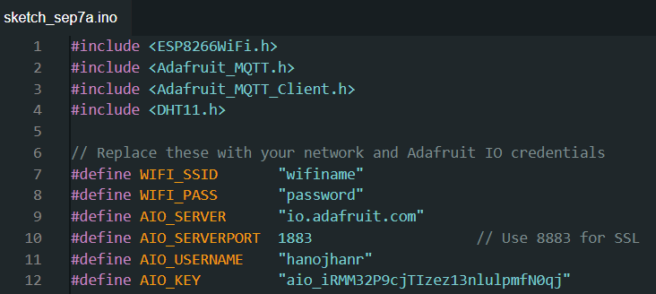
- Change WIFI_SSID and WIFI_PASS in your code to your Wi-Fi or mobile hotspot (Only Android works) ID and Password.

- Goto Adafruit -> IO -> Click API Key

- Change AIO_USERNAME and AIO_KEY in your code to your Adafruit Username and Active Key.

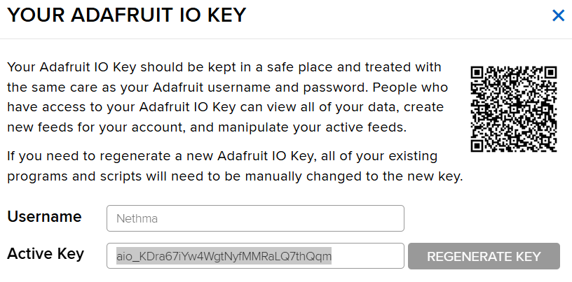

- Tools -> Serial Monitor -> Change to 115200baud

- Upload the code to NodeMCU and monitor the output from Serial Monitor and readings for temperature and humidity will be printed, and the data will be published to Adafruit IO.

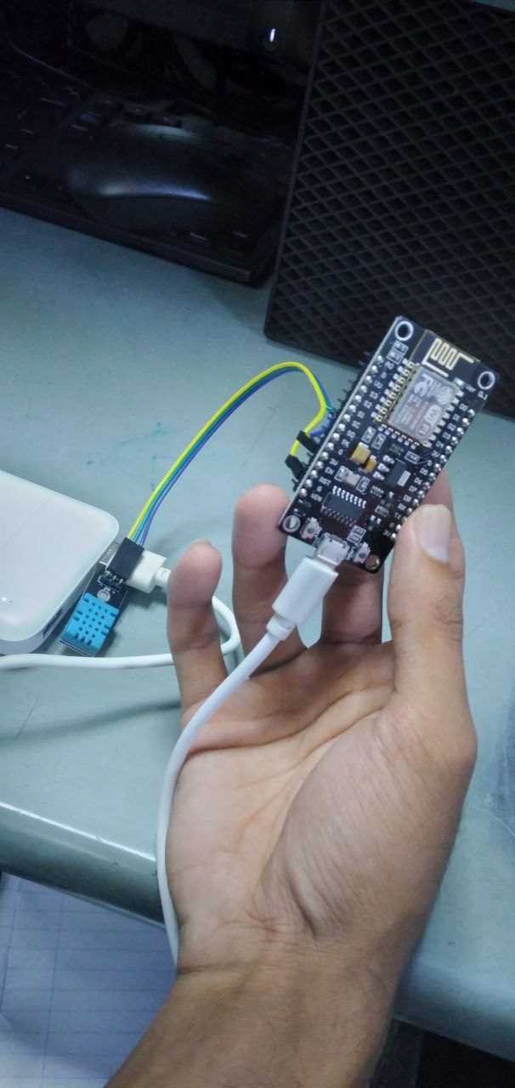

- We can use NodeMCU without connecting to the computer.
- NodeMCU is connecting to a powerbank.

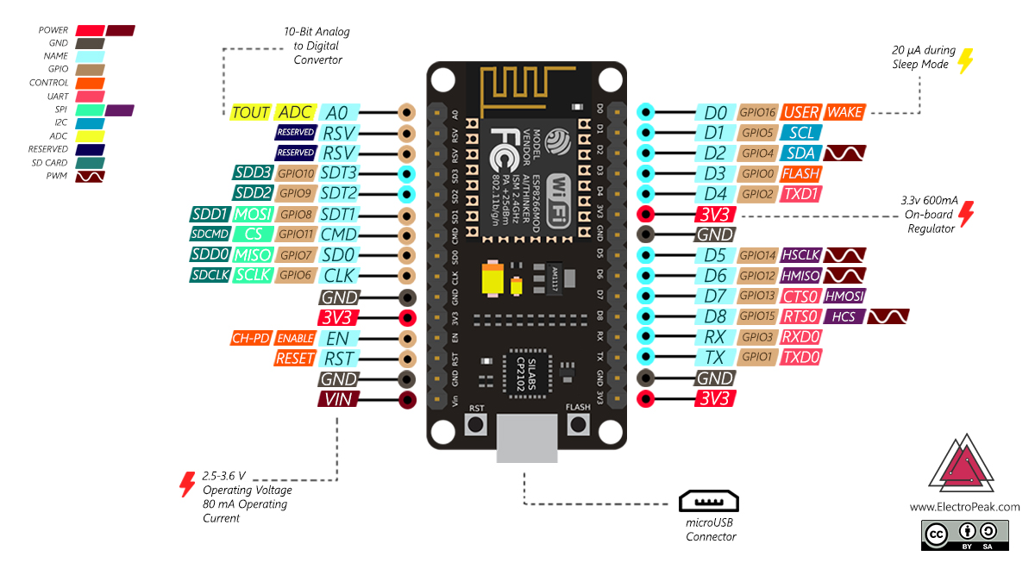

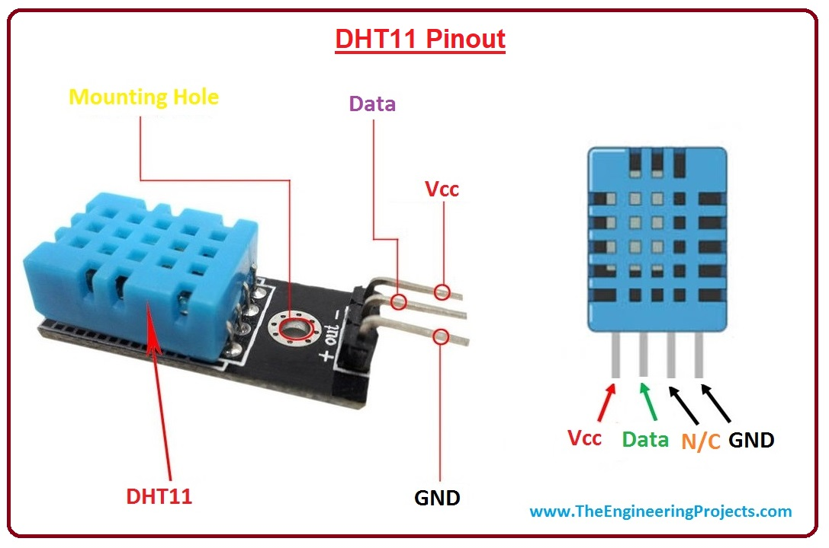

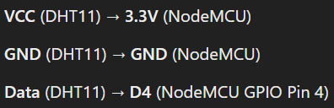
DHT11 -> NodeMCU
+ -> 3V
- -> G
Out -> D2

